|  |  |
| --- | --- |
| Assignment date | 01 November 2022 |
| Student Name | C.Atchaya |
| Student Roll number | 812419104011 |
| Maximum mark | 2 mark |

**QUESTION:**

1.Create html files 4 input boxes

a)name

b)email

c)qualification

d)age

(display above information in browser)

**SOLUTION:**

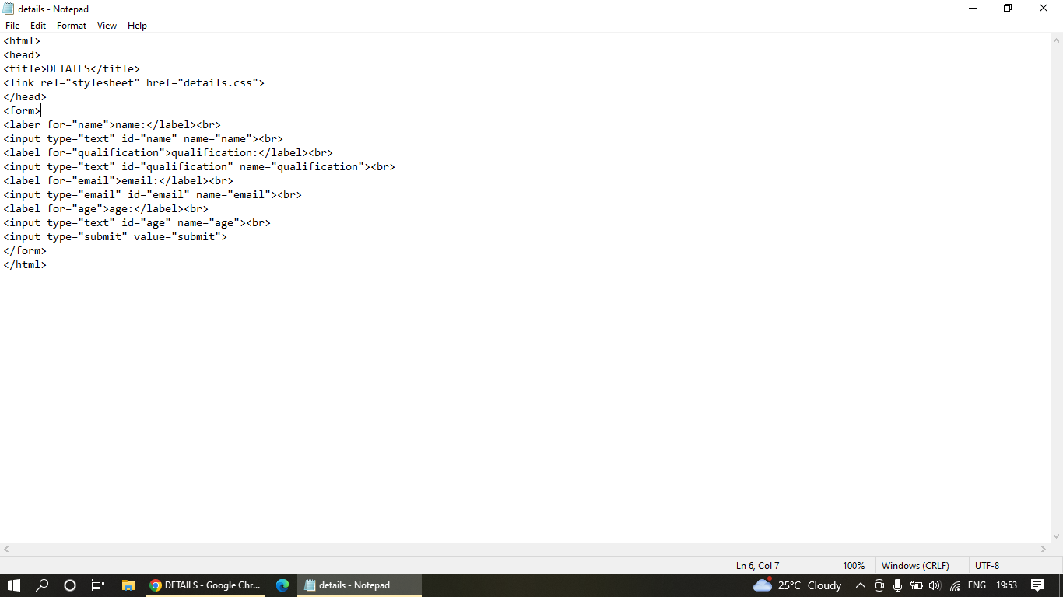

|  |
| --- |
|  |
|  |  |
|  |  |
|  | -name |
|  |  |
|  | -age |
|  |  |
|  | -submit button |
|  |  |

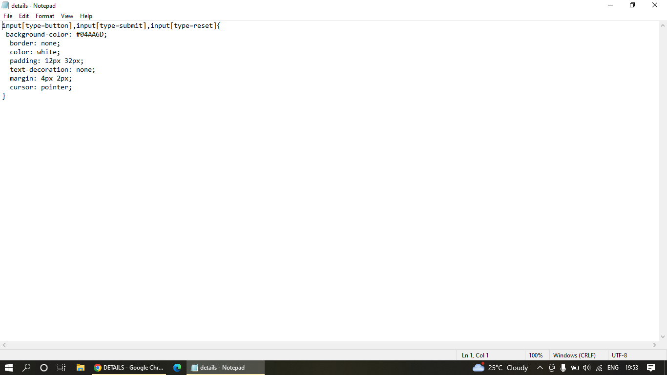

OUTPUT:

